**Title of Minor Project**

A Minor Project Report Submitted To

Rajiv Gandhi Proudyogiki Vishwavidyalaya, Bhopal

Towards Partial Fulfilment for the Award Of

Bachelor of Technology

In

**ARTIFICIAL INTELLIGENCE & DATA SCIENCE**

Submitted By

**Mani Chourasiya (0863EE211018)**

**Simran Pawar (0863AD211053)**

**Deepak Singh (0863AD211019)**



Under the Supervision of

**Prof./Dr./Asst. Prof. Guide Name**

Session: 2023-2024

**Department of Artificial Intelligence & Data science**,

**Prestige Institute of Engineering, Management and Research, Indore (M.P.)**

[An Institution Approved By AICTE, New Delhi & Affiliated To RGPV, Bhopal]

**PRESTIGE INSTITUTE OF ENGINEERING MANAGEMENTAND RESEARCH**

**INDORE (M.P.)**

**DECLARATION**

We **Mani Chourasiya, Simran Pawar,and Deepak Singh** hereby declare that the project entitled “**AI POWERED LEGAL DOCUMENTATION ASSISTANT”,** which is submitted by us for the partial fulfilment of the requirement for the award of Bachelor of Technology in Artificial Intelligence & Data Science to the Prestige Institute of Engineering, Management and Research, Indore (M.P.)*.* Rajiv Gandhi Proudhyogiki Vishwavidyalaya, Bhopal, comprises my own work and due acknowledgement has been made in text to all other material used**.**

Signature of Students:

Date:

Place:

**PRESTIGE INSTITUTE OF ENGINEERING MANAGEMENTAND RESEARCH**

**INDORE (M.P.)**

**DISSERTATION APPROVAL SHEET**

This is to certify that the dissertation entitled **“AI POWERED LEGAL DOCUMENTATION ASSISTANT”** submitted by **Mani Chourasiya (0863EE211018), Simran Pawar (0863AD211053), and Deepak Singh (0863AD211019)** to the Prestige Institute of Engineering, Management and Research, Indore (M.P.) is approved as fulfilment for the award of the degree of Bachelor of Technology in Artificial Intelligence & Data Science by Rajiv Gandhi Proudhyogiki Vishwavidyalaya, Bhopal, (M.P.).

**Internal Examiner External Examiner**

Date: Date:

**HOD, AI & DS**

**Dr. Dipti Chauhan**

**PIEMR, INDORE**

**PRESTIGE INSTITUTE OF ENGINEERING MANAGEMENTAND RESEARCH**

**INDORE (M.P.)**

**CERTIFICATE**

This is certified that project entitled “**AI POWERED LEGAL DOCUMENTATION ASSISTANT**” submitted by **Mani Chourasiya, Simran Pawar,and Deepak Singh**  is a satisfactory account of the bona fide work done under our supervision and is recommended towards partial fulfilment for the award of the degree Bachelor of Technology in Artificial Intelligence & Data Science to Rajiv Gandhi Proudyogiki Vishwavidyalaya, Bhopal (M.P.) .

**Date:**

**Enclosed by:**

Asst. Prof Diksha Bharawa Asst. Prof Diksha Bharawa Dr . Dipti Chauhan

**Project Guide Project Coordinator Professor & Head, AI&DS**

**Dr. Manojkumar Deshpande**

**Director**

**PIEMR, Indore**

**PRESTIGE INSTITUTE OF ENGINEERING MANAGEMENTAND RESEARCH**

**INDORE (M.P.)**

**ACKNOWLEDGEMENT**

After the completion of Minor project work, words are not enough to express my feelings about all these who helped me to reach my goal; feeling above this is my indebtedness to the almighty for providing me this moment in life.

First and foremost, we take this opportunity to express my deep regards and heartfelt gratitude to my project guide **Asst. Prof.** Diksha Bharawa **and Project Coordinator** Asst. Prof Diksha Bharawa**, Department of Artificial Intelligence & Data Science, PIEMR, Indore** for their inspiring guidance and timely suggestions in carrying out my project successfully. They are also the constant source of inspiration for me. Working under their guidance has been an opportunity for me to learn more and more.

We are extremely thankful to **Dr. Dipti Chauhan, (HOD, AI & DS)** for her co-operation and motivation during the project. I extend my deepest gratitude to **Dr. Manojkumar Deshpande, Director, PIEMR, and Indore** for providing all the necessary facilities and true encouraging environment to bring out the best of my endeavour’s.

We like to thank all the teachers of our department for providing invaluable support and motivation. I remain indebted to all the non-teaching staff of our Institute who has helped me immensely throughout the project.

We are also grateful to my friends and colleagues for their help and co-operation throughout this work. Last but not least; we thank my family for their support, patience, blessings and understanding while completing my project.

**Name of Students:**

**Mani Chourasiya (0863EE211018)**

**Simran Pawar (0863AD211053)**

**Deepak Singh (0863AD211019)**

**INDEX**

**Declaration I**

**Dissertation Approval Sheet II**

**Certificate III**

**Acknowledgement IV**

**Table of Contents V**

**List of Tables VI**

**List of Figures VII**

**TABLE OF CONTENTS**

# CHAPTER 1 INTRODUCTION

1.1 Introduction…………………………………………………………………….………2

1.2 Motivation………………………………………………………..............................2

1.3 Objective………………………………………………………………………………3

1.4 Analysis ………………………………………………………….............................3

1.4.1 Functional Requirements ………………………………………………......4

1.4.2 Non-functional Requirements ………………………………………………5

1.4.3 Use Case Diagram…………………………………………………………..6

# CHAPTER 2 BACKGROUND AND RELATED WORK

2.1 Problem Statement ……………………………………………………………………9

2.2 Background and Related Work………………………………………………………..9

2.2.1 Background Work …………………………………………………………..9

2.2.2 Literature survey ……………………………………………………….......12

2.3 Solution Approach (*methodology and technology used)…………*……………………16

# CHAPTER 3 DESIGN (UML AND DATA MODELING)

3.1 UML Modeling

3.1.1 Sub Systems………………………………………………………………….20

3.1.2 Modules Specification………………………………………………………..20

3.1.3 Collaboration Diagram ……………………………………………………….21

3.1.4 Class Diagram……………………………………………............................22

3.1.5 Sequence Diagram ………………………………………..........................22

3.1.6 Activity Diagram…………………………………………..........................23

3.2 Data Modeling

3.2.1 Data Flow Diagram………………………………………..........................24

# CHAPTER 4 IMPLEMENTATION

4.1 Tools Used…………………………………………………………………………...26

4.2 Technology…………………………………………………………………………...27

4.3 Testing ……………………………………………………………………………...28

4.3.1 Testing Approach. …………………………………………………………..29

4.3.2 Test Cases……………………………………………………………………31

4.3.3 Test Reports………………………………………………………………….34

4.3 User manual……………………………………………………………………………34

# CHAPTER 5 PROJECT PLAN

5.1 Gantt Chart………………………………………………………...............................39

5.2 Effort Schedule & Cost estimation ……………………………………………………39

5.3 Work Breakdown Structure…………………………………………………………….40

5.4 Deviation from original plan and correction applied………………………………..41

# CHAPTER 6: Project Screenshot

# CHAPTER 7 CONCLUSION & FUTURE SCOPE

7.1 Conclusion………………………………………………………..............................42

7.2 Future Scope…………………………………………………………………………42

**Bibliography……………………………………………………………………………….43**

**Appendix A: Snapshots or Screenshots with description………………………………44**

**LIST OF TABLES**

**1.Dataset sequence in CSV Format……………………………………………4**

**LIST OF FIGURES**

**CHAPTER 1**

**INTRODUCTION**

**1.1 INTRODUCTION:**

LegalEase is an innovative software application designed to streamline legal documentation processes. This software aims to revolutionize the legal profession by providing comprehensive assistance in document creation, legal research, and predictive analysis.

"LegalEase" aims to revolutionize the legal industry through advanced technology and automation. Its components include automated document generation, legal research tools, compliance monitoring, and risk assessment. This system promises increased efficiency, reduced costs, and broader access to legal services. It has the potential to transform how legal professionals operate, enabling them to focus on more complex tasks. However, challenges related to data security and regulatory compliance must be addressed. The future of "Legalese" could involve further advancements in AI and an expanded range of legal services. Overall, it represents a significant leap forward in modernizing legal practices.

"LegalEase" aims to save time for legal professionals, minimize legal risks, and ultimately enhance client satisfaction while adapting to the changing legal landscape and leveraging the power of data and analytics for informed decision-making.

“LegalEase” stems from the growing complexity of legal documentation and research. Legal Professional often face-time consuming tasks associated with drafting, researching and ensuring compliance.

**1.2 MOTIVATION:**

**“**LegalEase” is to transform and modernize the legal industry by improving efficiency, reducing costs, and increasing accessibility to legal services. This initiative is driven by a desire to automate routine legal tasks, streamline compliance, and provide innovative solutions that enhance the legal profession**.**

Legal professionals are often required to conduct in-depth legal research to support their cases. This process involves sifting through a vast amount of legal documents, statutes, case law, and regulations, which can be time-intensive.

With the demands of the legal profession, there is a growing need for tools and technologies that can streamline and automate various aspects of legal work, such as document creation, legal research, and analysis,analysis capabilities, which can assist in making informed decisions, assessing risks, and predicting legal outcomes, ultimately contributing to better legal strategies.

"Legalease" is to address the complexities and challenges faced by legal professionals, leverage the capabilities of AI and technology, and ultimately improve the efficiency, accuracy, and quality of legal services. This software aims to empower legal professionals by providing valuable assistance in legal documentation, research, and analysis.

* 1. **OBJECTIVE:**

“LegalEase” is to revolutionize the legal industry by harnessing technology and automation to enhance efficiency, accessibility, and cost-effectiveness in legal services. It seeks to simplify legal processes, reduce legal costs, and provide innovative tools and resources that make legal tasks more manageable.

"Legalease" aims to streamline and simplify the process of legal document creation. It is designed to assist legal professionals in generating a wide range of legal documents, including contracts, agreements, wills, legal letters, and more. The objective is to save time and reduce the manual effort required for drafting such documents.

One of the key objectives of "Legalease" is to provide legal professionals with efficient tools for conducting legal research. It offers access to an extensive database of statutes, case law, regulations, and legal precedents, making it easier for users to find relevant information and support their legal work.

The primary objectives of "Legalease" are to enhance the efficiency and quality of legal services, provide valuable assistance to legal professionals, facilitate collaboration, and promote compliance with legal and ethical standards. The software aims to meet the specific needs of legal professionals and organizations, ultimately improving their ability to create, research, and analyze legal documents.

**1.4 ANALYSIS:**

**1.4.1 Functional Requirements**

The functional requirements of "Legalease" encompass the specific features and capabilities that the software must possess to fulfil its intended purpose of assisting legal professionals in their work. Here are some key functional requirements for "LegalEase":

**1.Document Creation:**

The software should provide tools for creating a wide range of legal documents, including contracts, agreements, wills, legal letters, and more. Users should be able to customize document templates to meet their specific needs. "LegalEase" should support document version control, allowing users to track changes and revisions.

1. **Legal Research:**

"Legalease" should offer access to a comprehensive database of legal resources, including statutes, case law, regulations, and legal precedents. Users should be able to search, browse, and filter legal documents based on their research needs.

1. **Predictive Analysis:**

"Legalease" should employ machine learning algorithms to offer predictive analysis capabilities. Users should be able to input legal scenarios, and the software should provide insights into potential legal outcomes. The system should continuously update its predictive models based on the latest legal developments**.**

1. **Collaboration Tools:**

"Legalease" should support collaboration among legal professionals and teams. Users should be able to share and co-edit documents within the software. Version control features should ensure that changes are tracked and documented.

1. **User-Friendly Interface:**

The software should have an intuitive and user-friendly interface to ensure ease of use for legal professionals. Navigation should be straightforward, and the software should offer helpful tooltips and guides**.**

**6. Integration with Legal Tools:**

"Legalease" should integrate seamlessly with external legal tools and services, such as case management systems and e-discovery platforms. The software should allow for data sharing and communication between integrated systems.

**7. Educational and Training Features:**

For educational purposes, "Legalease" should provide practice and training modules for law students and legal professionals. Users should be able to access sample cases, conduct mock legal research, and practice document drafting

**1.4.2 Non-Functional Requirements:**

**1. Performance:**

**"**LegalEase" should respond to user actions promptly, ensuring that users experience minimal delay in interacting with the software. The software should be able to handle an increasing number of users and documents without significant performance degradation.

**2. Security:**

**"**Legalease" should employ robust data security measures to protect sensitive legal information. This includes data encryption, access controls, and secure data storage. The software should implement strong user authentication mechanisms to prevent unauthorized access to legal documents.

**3.Compliance:**

"Legalease" must comply with legal and ethical standards, including attorney-client privilege, data protection regulations, and legal ethics codes.

**4. Reliability:**

"Legalease" should be highly available, ensuring that users can access their legal documents and research resources when needed.

**5. Usability:**

"Legalease" should feature an intuitive and user-friendly interface that caters to users with varying levels of technical expertise**.**

**6. Scalability:**

"Legalease" should be designed to accommodate a growing user base and expanding data volumes. The software should scale horizontally or vertically as needed.

**7. Performance:**

"Legalease" should provide quick response times, ensuring that users experience minimal lag when accessing and interacting with legal documents.

**1.5 Use Case Diagram**

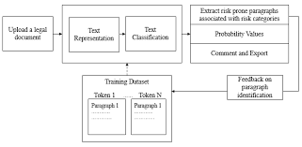

**CHAPTER 2 BACKGROUND AND RELATED WORK**

# 2.1 Problem Statement:

# A Problem statement for AI – POWERED LEGAL DOCUMENTATION ASSISTANT

“Legal documentation can be a complicated and time-consuming process, especially for individuals and small businesses who may not have access to legal resources. In addition, the language and jargon used in legal documents can be difficult for non-lawyers to understand, which can lead to errors and misunderstandings. Objective: The objective of this hackathon challenge is to develop an AI-powered solution that can simplify legal documentation for individuals and small businesses in India, by automatically drafting legal documents in plain language and using easy-to-understand terms”

**2.2 Background and Related Work**

**2.2.1 Background Work:**

LegalEase legal documents is a term often used to describe the complex and technical language commonly found in, contracts, statutes, regulations, and other legal texts. The purpose of using legalese is to provide precise and unambiguous language to convey legal conceptsand rights. Here are some key aspects of the background work of LegalEase. Legal documents often include specialized terminology and Latin phrases. These terms have specific legal meanings and help to make legal language more precise. LegalEase is a specialized language used in the legal field to create documents that are precise, unambiguous, and legally binding. It is characterized by its formality, tradition, and use of specific terminology. Legal professionals use legalese to ensure that legal documents accurately convey their intended legal effects.

**Some of the common steps involved in Legal Documentation Assistant:**

**1.Data Collection:** This involves gathering text data from various social media sources, such as Twitter, Facebook, Instagram, etc. The data can be filtered by keywords, hashtags, mentions, or other criteria.

**2.Data Preprocessing:** This involves cleaning and transforming the text data into a suitable format for analysis. Some of the common techniques include tokenization, normalization, lemmatization, stemming, stop word removal, etc

**3.Feature Extraction:** This involves selecting and extracting relevant features from the text data that can represent the sentiment behind them. Some of the common features include word frequency, n-grams, part-of-speech tags, sentiment lexicons, etc.

**4.Model Training:** This involves using a machine learning algorithm to learn from the features and labels of the training data and create a sentiment classifier. Some of the common algorithms include logistic regression, naive Bayes, support vector machines, decision trees, neural networks, etc

**5.Model Evaluation:** This involves testing the performance of the sentiment classifier on unseen data and measuring its accuracy, precision, recall, F1-score, etc.

**6.Model Deployment:** This involves applying the sentiment classifier to new text data from social media and obtaining the sentiment scores or categories for each text.

This involves studying the legal industry to understand its specific needs, challenges, and emerging trends. It also includes competitor analysis to identify existing solutions and gaps that "Legalease" can address.

* AI and NLP Integration
* Legal Compliance and Security
* Legal Databases Integration
* Predictive Analysis Implementation**.**

**2.2.2 Literature survey**

This section illustrates other similar work related to AI POWERED LEGAL DOCUMENTATION ASSISTANT. The AI legal documentation assistant, involves reviewing existing literature and research related to AI applications in the legal field, document automation, and similar technologies. Below is a simplified overview of potential areas to explore in a literature survey for "Legalease":

**AI in Legal Services:**

Investigate the adoption of AI in the legal industry and its impact on legal services, including document generation, contract analysis, and legal research .Examine literature on document automation tools and their role in improving efficiency and reducing errors in legal document preparation. Review studies and research papers on NLP techniques used for legal document analysis ,summarization, and information retrieval.

**OCR and Text Extraction:**

Explore research on OCR technology, its advancements, and its applications in extracting text from images and scanned documents. Explore how AI and machine learning are used for predictive analysis in legal scenarios, such as predicting case outcomes.

**Ethics and Compliance:**

Investigate the ethical and compliance aspects of AI usage in the legal field, including attorney-client privilege and data protection regulations.

Review literature on UX design principles in legal software, which can influence the design of "Legalease" to ensure user-friendliness.

**Legal Research Databases:**

Explore resources and databases used for legal research and how "Legalease" can integrate with or leverage such resources.

**Regulations and Compliance**:

Examine how AI-powered legal tools should adhere to specific legal and ethical regulations, such as the American Bar Association's Model Rules of Professional Conduct. Investigate emerging trends and technologies in the legal tech sector that could influence the development and adoption of AI legal documentation assistants like "Legalease.”

**2.3 Solution Approach (methodology and technology used)**

**METHODOLOGY-**

**Data Collection:**

Collect social media data from Twitter, including comments or tweets related to the product or topic of interest.

**Data Preprocessing:**

Clean and preprocess the collected data. This may involve removing irrelevant information, handling special characters, and tokenizing the text.

**Sentiment Analysis:**

Apply a pre-trained NLTK model for sentiment analysis. This model will classify the text into positive, negative, or neutral sentiments based on the content.

**Visualization:**

Visualize the sentiment analysis results. Categorize and present the comments as positive, negative, or neutral, allowing users to easily interpret the sentiment of each comment.

**Website Integration:**

Integrate the sentiment analysis tool into a website or web application, ensuring it is user-friendly and accessible to visitors.

**User Interaction:**

Enable users to interact with the integrated tool on the website. Users can input different comments or tweets for analysis.

# CHAPTER 3

# DESIGN (UML AND DATA MODELING)

# Dialogue-guided intelligent document processing with foundation models on Amazon SageMaker JumpStart | AWS Machine Learning Blog

# CHAPTER 4 IMPLEMENTATION

**4.1 Tools and Technology:**

1. Natural Language Processing (NLP) Libraries:

* NLTK

1. Machine Learning and Deep Learning Frameworks:

* Scikit-Learn
* Pandas
* Numpy
* Flask
* Tensorflow

1. OCR:

OCR such as Tool can be used todocument validation.

1. Data Collection and Scraping Tools:

APIs provided by social media platforms (Kaggle,and other Api) for accessing legaldata.

1. Data Preprocessing Tools:

* **Python Image Library**
* **Metadata Extractors**
* **Regular Expression.**

your Ttack here: 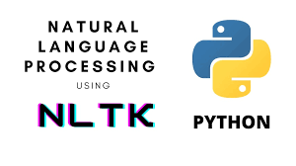



# CHAPTER 5

# PROJECT PLAN

**5.2. Effort Schedule & Cost estimation**

**Effort Schedule:-**

**Project Initiation:**

Define project objectives: 1 day

Gather project requirements: 2 days

Develop project plan: 1 day

Total duration: 4 days

**Data Collection:**

Collect social media data: 3 days

Data preprocessing: 1 day

Total duration: 4 days

**Model Development:**

Pre-trained model selection: 2 days

Model evaluation: 1 day

Total duration: 3 days

**Document Generation and Scanning:**

Document Generations: 3 days

Document Scanning: 2 days

Total duration: 5 days

**Report and Presentation:**

Generate project report: 1 day

Prepare project presentation: 1 day

Total duration: 2 days

**Project Review and Closure:**

Review project outcomes: 2 days

Project documentation: 1 day

Total duration: 3 days

Total Project Duration: Approximately 21 days

Please note that these are rough estimates, and the actual effort required may vary based on the complexity of your project.

**Cost Estimation:-**

There is no need of any type of expenses in our project.

# CHAPTER 6

# PROJECT SCREENSHOT

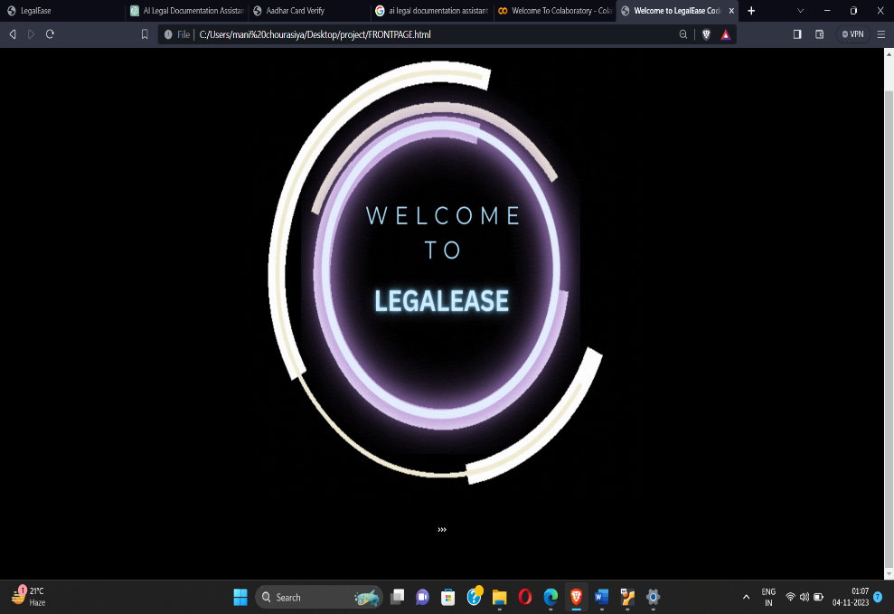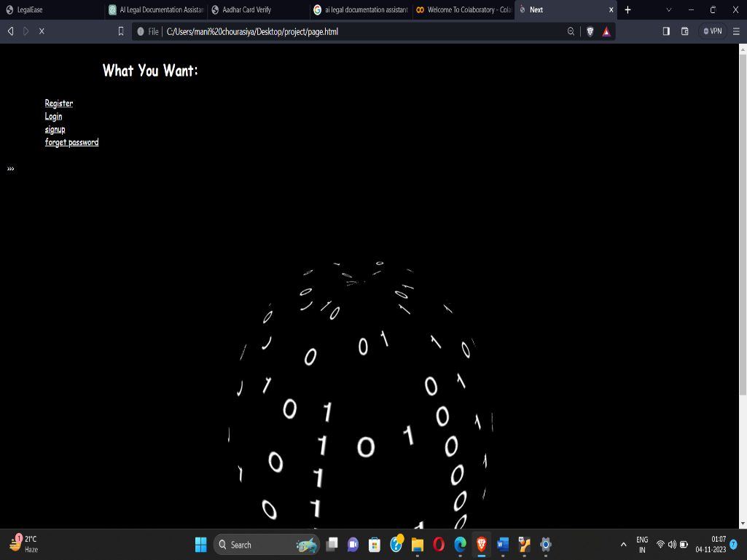

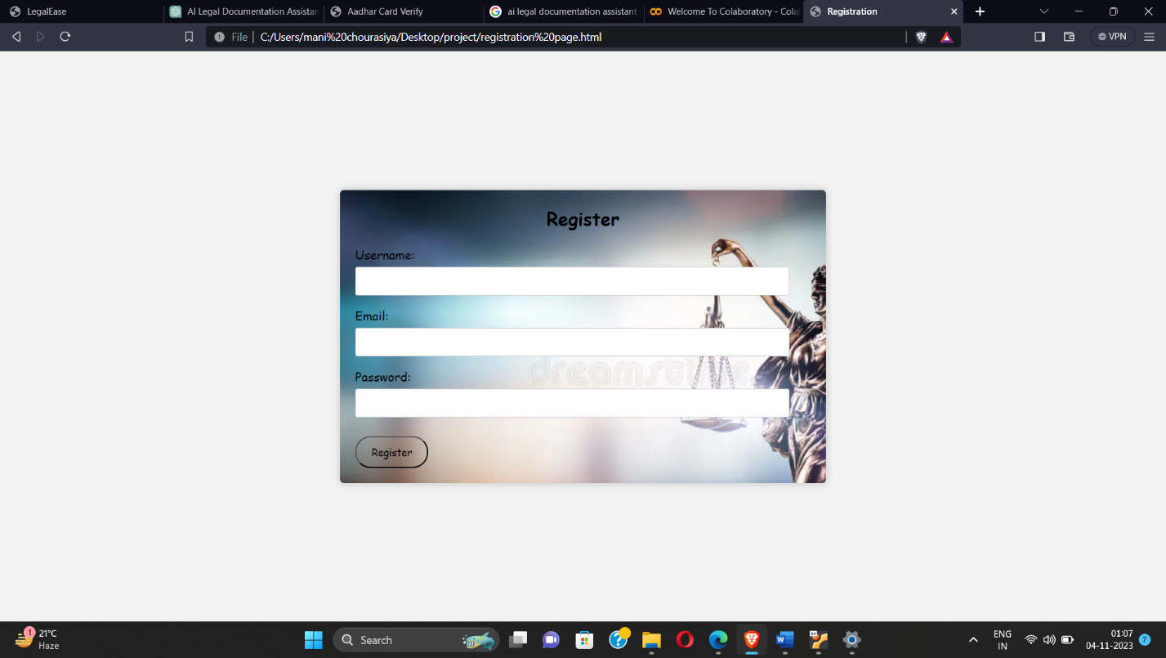 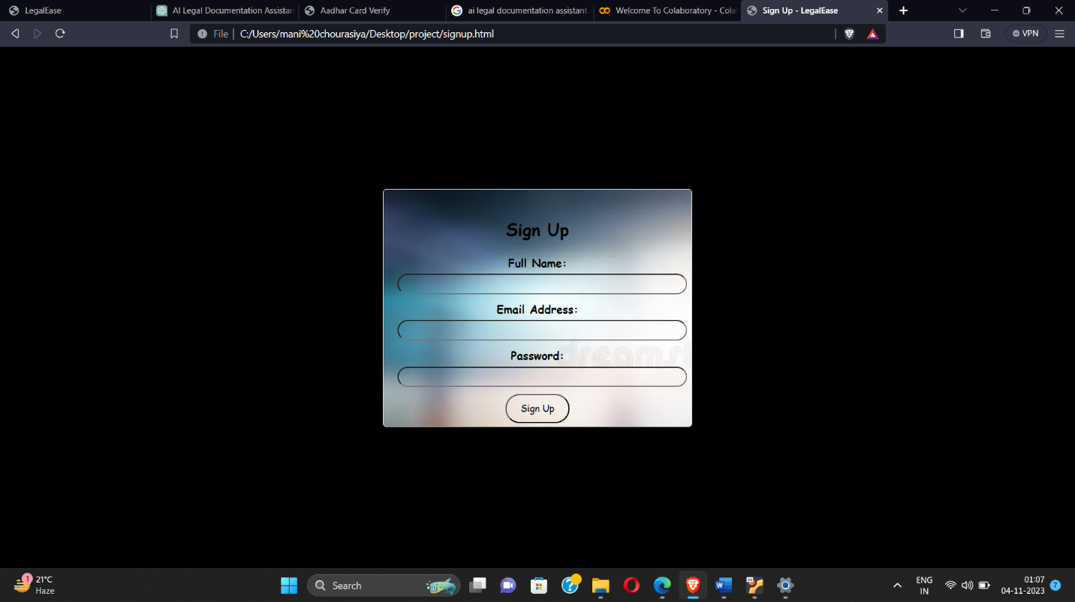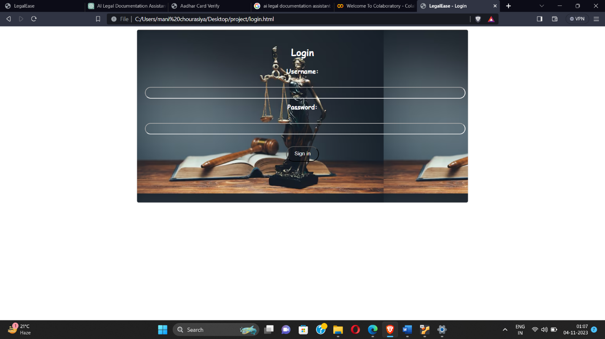 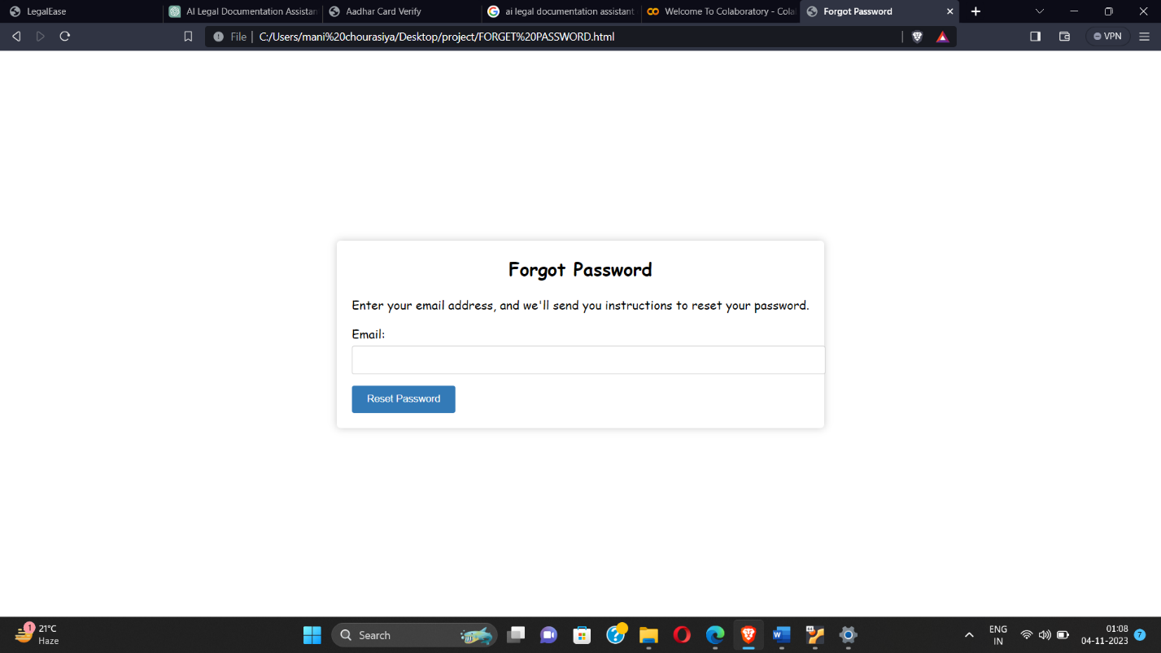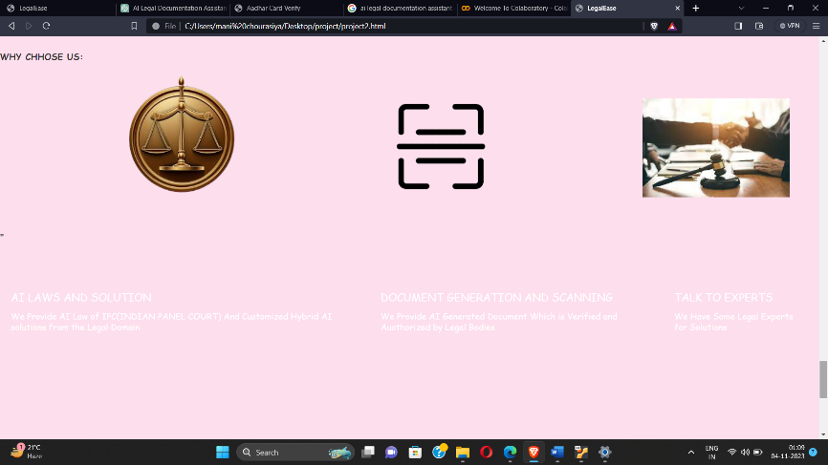

# CHAPTER 7

# CONCLUSION & FUTURE SCOPE

**7.1 Conclusion**

In conclusion, "Legalease" stands as a pioneering innovation in the legal tech landscape, offering a comprehensive solution to address the evolving needs of the legal profession. This AI-powered legal documentation assistant streamlines and enhances various aspects of legal work, from automated document generation to in-depth legal research and predictive analysis .

"Legalease" brings efficiency and accuracy to legal document preparation, significantly reducing the time and effort required for this crucial task.

It empowers legal professionals with easy access to extensive legal resources, enhancing the quality and depth of legal research and analysis. Beyond document generation, its predictive analysis features enable informed decision-making and the development of effective legal strategies based on historical data and machine learning algorithms.

The software's user-friendly interface ensures accessibility for legal professionals of varying technical expertise, while its integration with other legal tools and services creates a unified and productive workflow.

"Legalease" is not only a powerful tool for legal firms but also serves as an educational and training platform for law students and professionals. Its commitment to data security and compliance with legal and ethical standards ensures the protection of sensitive legal information, maintaining the privacy and security vital in the legalprofession.

By embracing "Legalease," the legal community can adapt, remain competitive, and continue to deliver high-quality legal services in an ever-changing industry.

**7.2 Future Scope**

**1. Advanced AI Capabilities:** "Legalease" can continue to evolve by incorporating more advanced AI capabilities, including natural language understanding and improved machine learning models. This would enhance its ability to understand complex legal documents, legal language, and nuances in legal texts.

2.**Multilingual Support:** Expanding language capabilities to cover a wider range of languages and legal systems can make "Legalease" more accessible to a global audience. Multilingual support would cater to the needs of law practitioners worldwide.

**3. Customization and Templates**: The ability for users to customize templates and create their own document automation workflows can empower legal professionals to tailor "Legalease" to their specific needs and practice areas.

4**. Collaboration and Communication:** Integrating collaboration features such as real-time document co-editing, secure client communication, and case management can further improve the efficiency and workflow within law firms and legal departments.

**5. Mobile Accessibility:** Developing mobile applications and optimizing the user interface for mobile devices can enhance accessibility, allowing legal professionals to work on legal documents and research while on the go.

**6..Enhanced Legal Research**: Expanding the integration of legal databases and resources, and providing more advanced legal research capabilities, can help users access a broader spectrum of legal information.

**7. Predictive Analytics:** "Legalease" can evolve into a tool that not only analyzes past legal cases but predicts legal outcomes and provides recommendations for legal strategies. This could be particularly valuable in litigation and dispute resolution.

**8. Regulatory Compliance:** Monitoring: Providing features for monitoring and ensuring regulatory compliance can assist legal professionals in staying up-to-date with changing legal requirements and ensuring their clients' businesses are in compliance.

**9. Continuous Learning and Training:** Offering ongoing training modules, continuing legal education (CLE) credits, and professional development opportunities within "Legalease" can help legal practitioners stay current with legal trends and requirements.

**10. Blockchain and Smart Contracts**: Integrating blockchain technology for securely managing and executing smart contracts, as well as ensuring the authenticity and integrity of legal documents, can be a future enhancement.